**Group Meetings**

**Meeting Minutes #1**

Date: 2/3/2015

Time: 1730 – 1830

Agenda

* Getting a better understanding on the project

Minutes

* To gain better understanding on the project at hand, multiple videos with relevance to the Oculus Rift, Leap Motion and typing tutors were watched.
* After watching videos on the subject, questions that were relevant to the project were recorded. The questions will then be directed to our advisor and clarified.

Action Items

* Have another meeting among the group members the following week

**Meeting Minutes #2**

Date: 3/3/2015

Time: 1430 – 1530

Agenda

* Meeting up with advisor for the first time
* Gain clarification on questions which were formed on the first meeting

Minutes

* Advisor gave us a brief overview on the project. The different hardware that we will be working with (Oculus Rift and Leap Motion) and also the possible game engines (Source, Unity) that can be used for the project. Unity will be used for the development of the project. Knowledge on the game engine and C# is required. We were told to go through documentation or the tutorials available online on both the game engine and the hardware. Other hardware were briefly mentioned, such as the Kinect and Nimble.
* Different versions of the program can be developed, one that works with the Oculus Rift and one without the Oculus Rift.
* A brief talk on electro tactile feedback conditioning, and existing typing tutors which relies on repetitive typing to train the user. Also talked about associating animal voices or the alphabet song into different keys which will allow the user to have a more intuitive learning.
* Talked about different approaches to different stages of the game, for example, in stage 1, lighting up the finger required to type the prompted key, providing training exercise for the user (prompting a key and wait for the user to respond), providing statistics to the user, compete with other players, a positive sound when user hits the correct key/a negative sound when user hits the wrong key, and for the second stage the user is required to shoot lasers to a virtual keyboard (Keys prompted will light up) on keys they are prompted with.
* We then talked about how diaries should be submitted every day after a meeting, and a person would be in charge of forming the group meeting minutes after collecting the individual diaries.
* Dyalan and Elle assigned to look on tutorials on the proper way to type.
* Kapil is to work on the introduction.
* Wee is assigned with coming up with the requirements draft.

Action Item

* Tutorials on proper way to type (Elle and Dyalan)
* Learning the Leap Motion SDK and Unity
* Requirements draft (Wee)
* Introduction (Kapil)
* Diaries on what is done throughout the week

Meeting Minutes #3

Date: 8/3/2015

Time: 1430 – 1600

Agenda

* Meeting up with each other to get a better understanding of the hardware and the provided SDK

Minutes

* We installed the SDK files onto our PCs and tried out the available applications.
* We looked at a few YouTube links on the development of simple Leap Motion applications. The assets provided in the downloaded SDK were used in Unity which allows easier development on the Leap Motion. C# codes were also used for the development of the simple application. (Links: <https://www.youtube.com/watch?v=Fyk0F--43Cw>, <https://www.youtube.com/watch?v=MBbWcniM0BM>)
* We take a look at a simple application developed on Unity by Elle and Dyalan. It was a ball moving on a surface which can be moved by receiving inputs from the keyboard.
* We tried the code provided in the SDK file where the LeapMotion would constantly detect for movement on it.

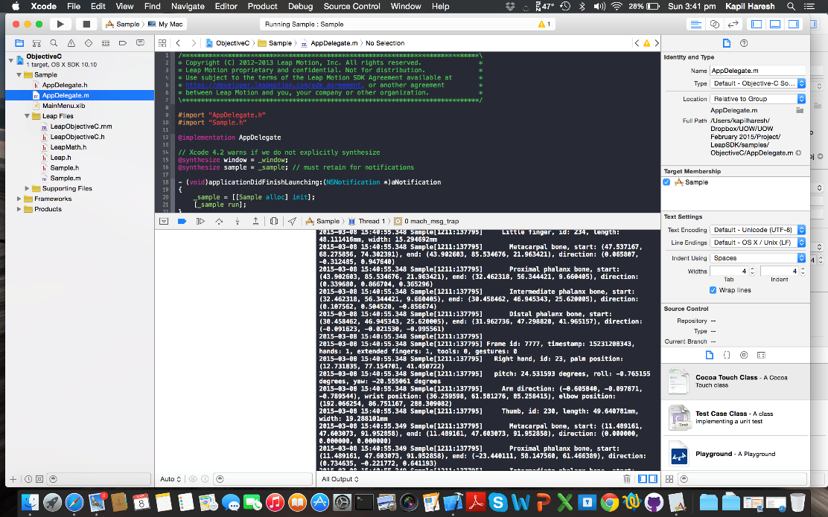

* Listed a few questions that will be directed to the advisor on the upcoming Tuesday.

Action Item

* Meeting up with the advisor and group members on the upcoming Tuesday.

Meeting minutes #4

Date: 9/3/2015

Time: 1715 – 1745

Agenda

* To clear up misunderstandings on the projects

Minutes

* As the lecturer would not be able to meet us on Tuesday and there were misunderstandings among group members which might result in no progress being made, we have decided to have a quick meeting under a tree beside UniBar.
* Among issues to be resolved were related to stage two of the project and how to move on from our current point. We have already take a brief look on how to work with the Leap Motion SDK on Unity via YouTube videos, but was not sure if we were to develop on Unity.
* Taking two weeks to learn Unity and C# respectively seems to be too time consuming. We decided that we will rely on the existing Leap Motion/Unity development tutorials that are available online, especially from YouTube. We will learn both C# and development on Unity as we move on with the development of the project.
* Due to the fact that there is only 1 Leap Motion in hand, we have decided to split the work among us on the development and the documentation.
* Elle and Dyalan would be involved in the development of the first stage of the Typing Ninja. We then broken down the tasks that must be done from detecting fingers of the leap motion to highlighting the finger as the alphabets are prompted. This is detailed in another document which will be done by Wee.
* Wee and Kapil will be working on the documentation side of things as too many people involved in the development would make it quite messy. Kapil has decided to start working on the presentation that will be used in the upcoming weeks. The introduction will come after the completion of the slides. Besides working on the document to given to the 2 developers, Wee will be working on testing out exsiting typing tutors on the market. Kapil will also be working on this (This idea came from today’s lecture on comparing different products on the market). The purpose of testing existing typing tutors is to help us come up with more requirements for our Typing Ninja. We will look at functionalities that are provided by the typing tutor and list the desired functionalities for our own typing tutor.
* We will help each other upon completion of assigned tasks. The design methodology that we decided to take on will be a form of prototyping. Instead of prototyping the whole game in one go, we will be prototyping by stages to be shown to the lecturer upon completion.

Action Item

* Development of first stage of Typing Ninja (Dyalan and Elle)
* Comparing existing typing tutors on the market (Kapil and Wee)
* Presentation slides and introduction (Kapil)
* Stage 1 development check list for Elle and Dyalan (Wee)